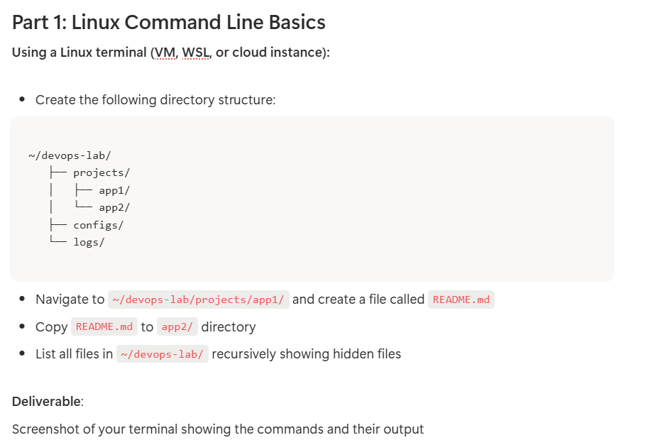
Soution:
- Create the following directory structure
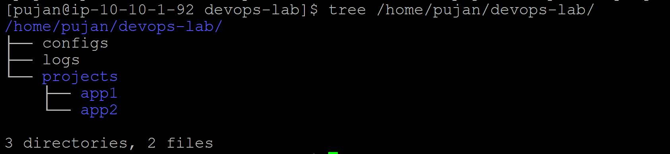
- Navigate to ~/devops-lab/projects/app1/ and create a file README.md
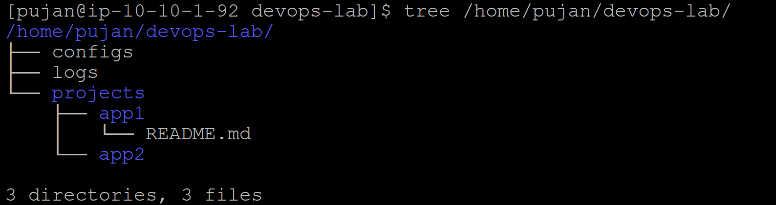
- Copy README.md to app2/ directory
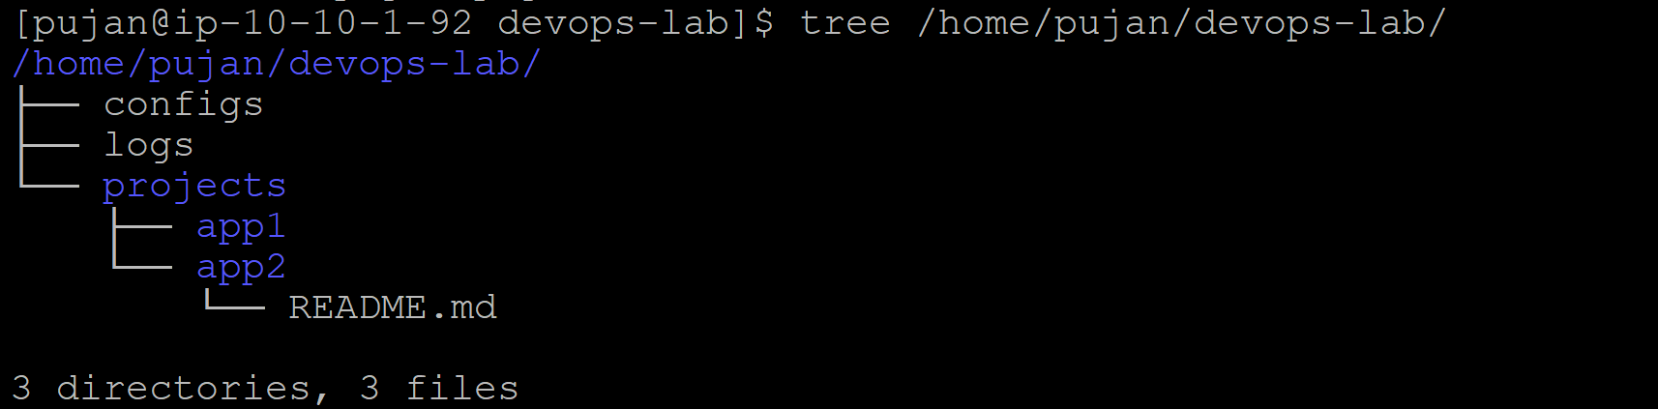
- List all files in ~/devops-lab/ recursively showing hidden files:
